**Assignment -1**

Python Programming

|  |  |
| --- | --- |
| Assignment Date | 19 September 2022 |
| Student Name | MUGESHWARI |
| Student Roll Number | 51119106003 |
| Maximum Marks | 2 Marks |

TO COUNT NUMBER OF LETTER IN GIVEN WORD

|  |
| --- |
| countOfWords = len("Geeksforgeeks is best Computer Science Portal".split())  print("Count of Words in the given Sentence:", countOfWords)  print(len("Geeksforgeeks is best Computer Science Portal".split()))  print(len(input("Enter Input:").split())) |

**Output:**

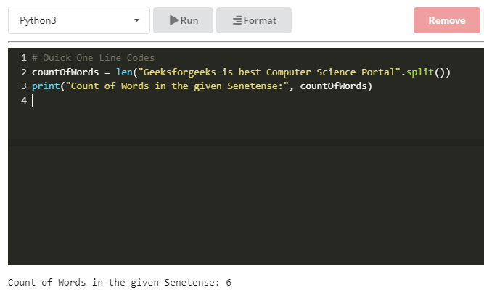

**Using split()** split function is quite useful and usually quite generic method to get words out of the list, but this approach fails once we introduce special characters in the list.

* Python3

|  |
| --- |
| # Python3 code to demonstrate  # to count words in string  # using split()    # initializing string  test_string = "Geeksforgeeks is best Computer Science Portal"    # printing original string  print ("The original string is : " +  test_string)    # using split()  # to count words in string  res = len(test_string.split())    # printing result  print ("The number of words in string are : " +  str(res)) |

**Output:**The original string is : Geeksforgeeks is best Computer Science Portal The number of words in string are : 6

**Method #2 : Using regex(findall())** Regular expressions have to be used in case we require to handle the cases of punctuation marks or special characters in the string. This is the most elegant way in which this task can be performed.

**Example**

* Python3

|  |
| --- |
| # Python3 code to demonstrate  # to count words in string  # using regex (findall())  import re    # initializing string  test_string = "Geeksforgeeks,    is best @# Computer Science Portal.!!!"    # printing original string  print ("The original string is : " +  test_string)    # using regex (findall())  # to count words in string  res = len(re.findall(r'\w+', test_string))    # printing result  print ("The number of words in string are : " +  str(res)) |

**Output:**The original string is : Geeksforgeeks, is best @# Computer Science Portal.!!! The number of words in string are : 6

**Method #3 : Using sum() + strip() + split()** This method performs this particular task without using regex. In this method we first check all the words consisting of all the alphabets, if so they are added to sum and then returned. 

* Python3

|  |
| --- |
| # Python3 code to demonstrate  # to count words in string  # using sum() + strip() + split()  import string  # initializing string  test_string = "Geeksforgeeks,    is best @# Computer Science Portal.!!!"    # printing original string  print ("The original string is : " +  test_string)    # using sum() + strip() + split()  # to count words in string  res = sum([i.strip(string.punctuation).isalpha() for i in test_string.split()])    # printing result  print ("The number of words in string are : " +  str(res)) |

**Output:**The original string is : Geeksforgeeks, is best @# Computer Science Portal.!!! The number of words in string are : 6

**Method #4: Using count() method**

* Python3

|  |
| --- |
| # Python3 code to demonstrate  # to count words in string    # initializing string  test_string = "Geeksforgeeks is best Computer Science Portal"    # printing original string  print ("The original string is : " + test_string)    # to count words in string  res = test_string.count(" ")+1    # printing result  print ("The number of words in string are : " + str(res)) |

**Output**

The original string is : Geeksforgeeks is best Computer Science Portal

The number of words in string are : 6